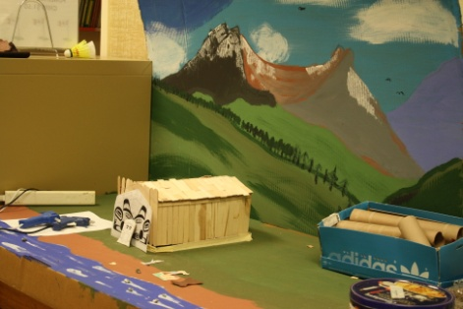
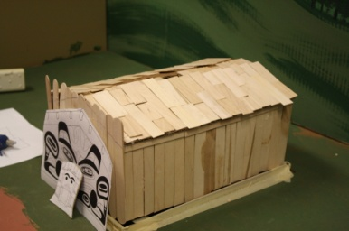
Feb 21-24: Monday to Thursday
Feb 28-Mar 3: Monday to Thursday
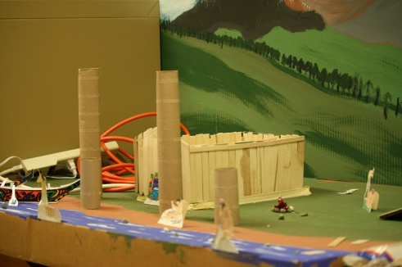
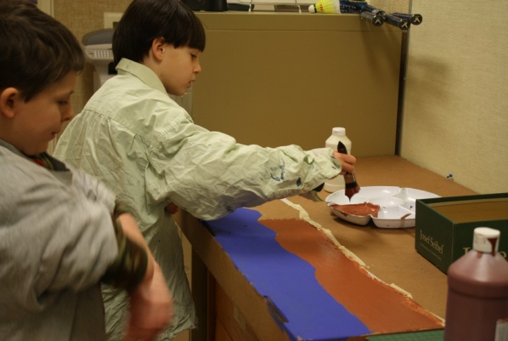
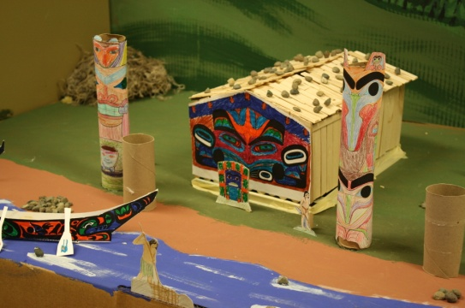
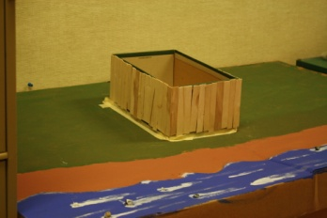
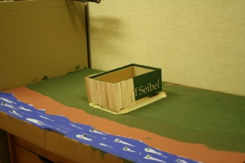
Spring Break !

March 14th to March 25th
This week, during our field trip we enjoyed an Imax Movie “Arabia”. In the Museum, we visited the section about old time BC logging, mining, farming and even a fish cannery. We stepped aboard Captain Vancouver’s ship, the “Discovery”. We also explored fur trade artifacts. Everyone enjoyed the tour.
PAC Bottle Drive

Saturday March 5th
The Grade 4’s have completed their West Coast Aboriginal village including a longhouse, canoes, woven mats, totem poles, bentwood boxes and much more. You should come and have a look at their great effort.
Our Salmon Eggs Have Arrived
A big thank you to Rick Jones for setting up our fish tank so that we can raise 200 salmon eggs this year. The students will watch their development over the coming months and record their progress. The fry will be released into a local stream when they are fully developed.
Upcoming Dates

Feb 22nd Field Trip to the Royal British Columbia Museum and Victoria Gymnastics
Report Cards will be issued
March 7th.
Valentine’s Day

We had great fun on Monday February 14th celebrating Valentine’s day. We made, and elaborately decorated, a heart shaped (sort of) cake. Thanks Lynn for all the decorations. The kids enjoyed cream soda floats.

